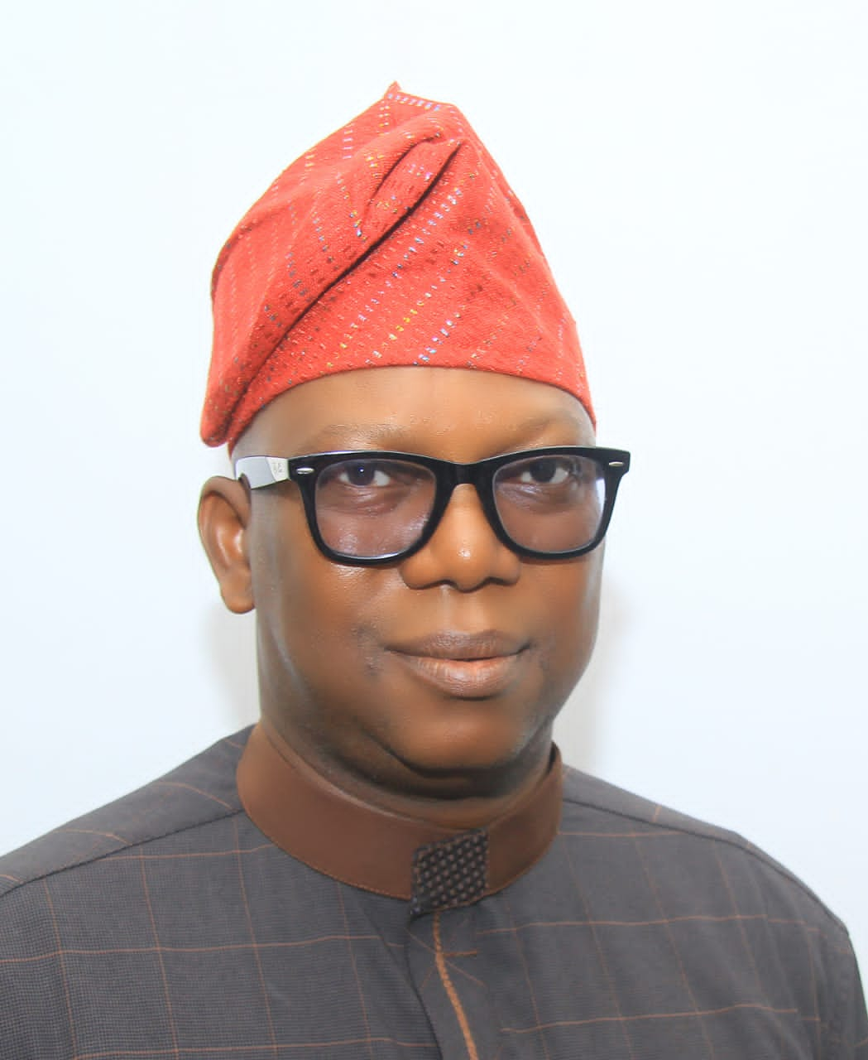

**DR. IDRIS ODEKUNLE, MANAGEMENT MEMBER**